# Validation Test

## Logging in

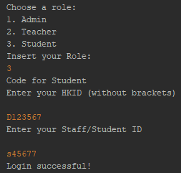

When logging in, the user has to input their role, HKID and staff/student ID. If the correct information is inputted, the program will display “Login successful!”.

## Admin assigns roles to existing users

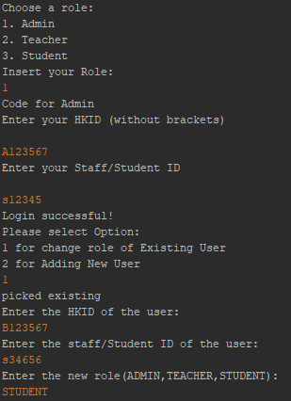

The admin can change the role of existing users. For example, in the above image the HKID ‘B123567’ refers to a teacher. To change their role, the user will have to input the HKID, staff ID and the new role to update the role of the existing user.

## Teacher uploading assignments

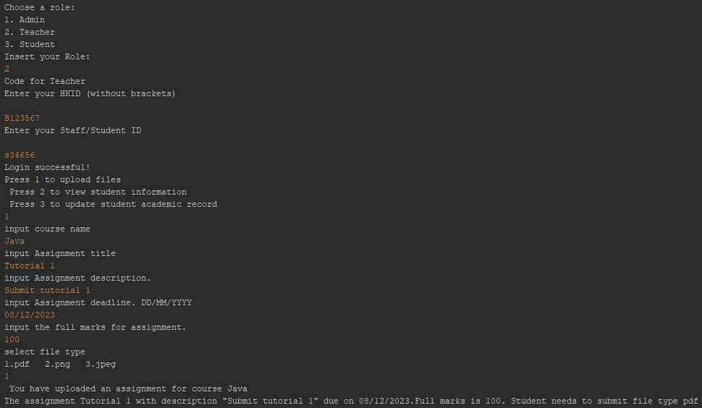

The teacher can upload assignments by first logging in. Then inputting the course name, assignment title, description, deadline, full marks, and the file type of the assignment. When all this information is inputted, the statement with all that information will be printed out. In the above image, the statement is “The assignment Tutorial 1 with description "Submit tutorial 1" due on 08/12/2023.Full marks is 100. Student needs to submit file type pdf”

## Teacher updating student’s grades

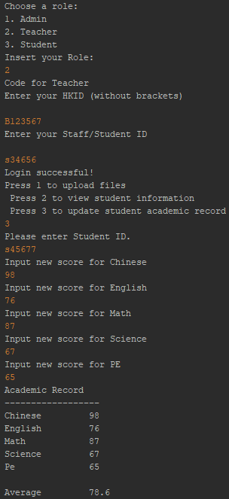

The teacher can update student’s grades by inputting the student’s ID, and their new grades. The program will then output the student’s grades.

## Student viewing their personal information/academic record

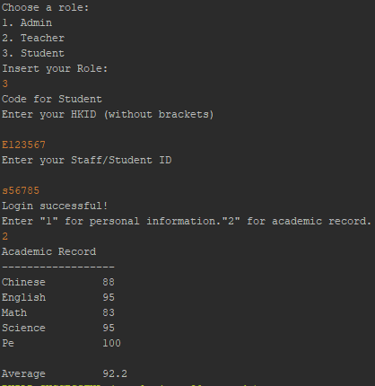

The student can view their personal information/grades by logging in then inputting ‘1’ for personal information or ‘2’ for academic record. In the above image, the user inputted ‘2’ which then displayed the student’s academic record.

### 

## Student updating their personal information

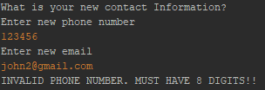

The phone number must have 8 digits to be valid.

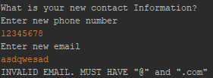

The email must have an “@” and a “.com” to be valid.

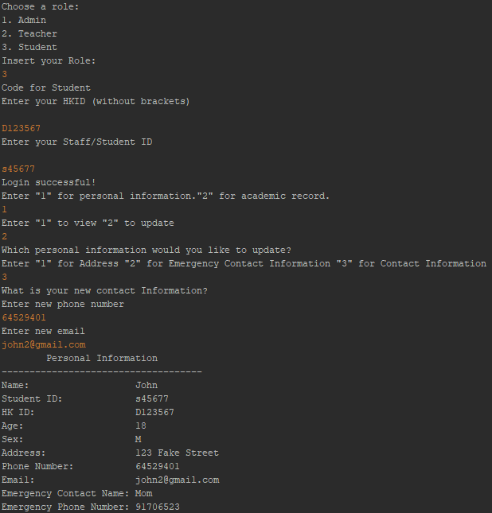

The student can update their personal information by logging in then inputting their new phone number and email, which will then output their personal information with the updated phone number and email.

# Defect Testing

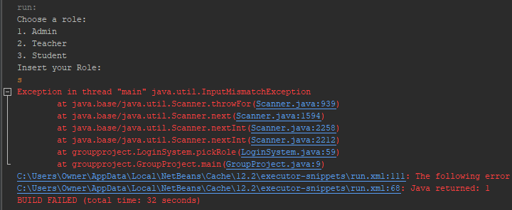

When choosing role, if you input a non-number such as a character, it will cause errors

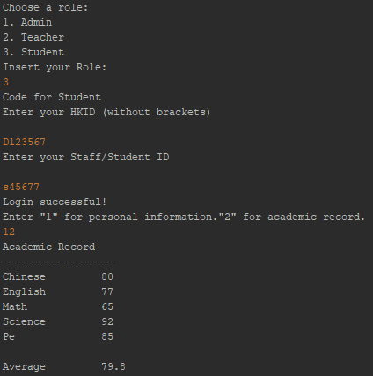

When typing a number that is out of range, it still goes to the next part. In the image above, the user has to input 1 for personal information and 2 for academic record. But, the user inputted ‘12’ and it still went to view the academic record.

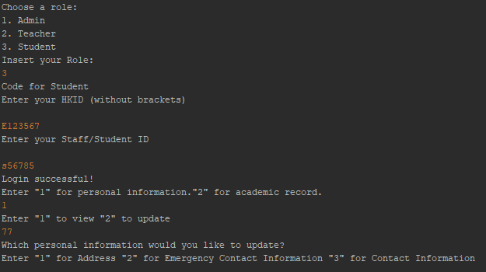

When typing a number that is out of range, it still goes to the next part. In the image above, the user has to input 1 to view and 2 to update. But, the user inputted ‘77’ and it still went to update.

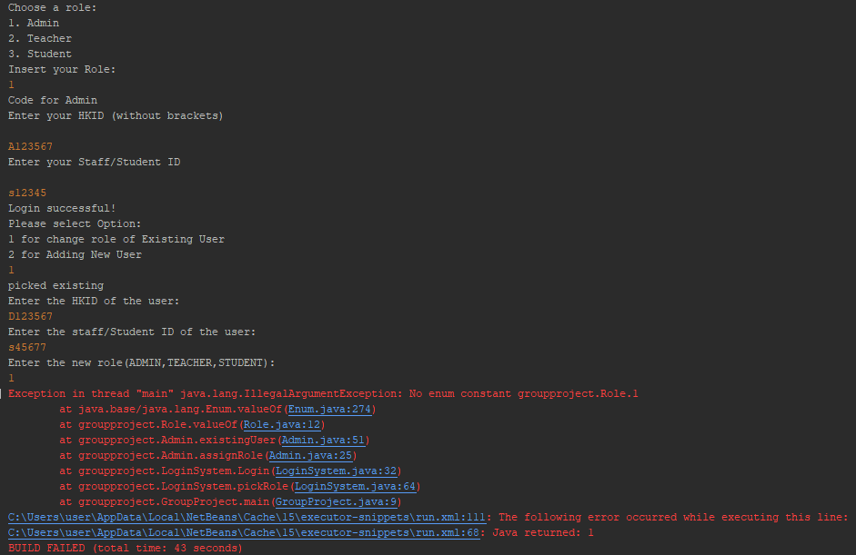

When logged in as an admin and updating an existing user’s role, if the user inputs the role as ‘1’ the program crashes.

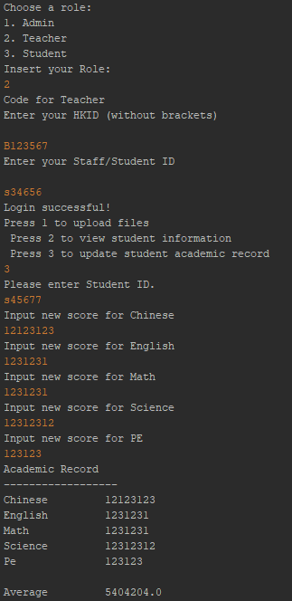

There’s no limit to the grades of the student. Any number can be inputted.

# Development Testing

## Unit test

Viewing a student’s personal information

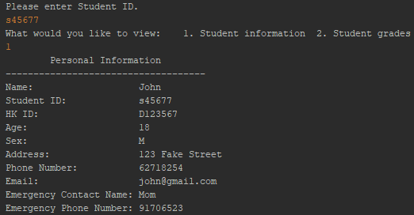

Create new user

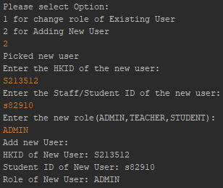

Updating a student’s grades

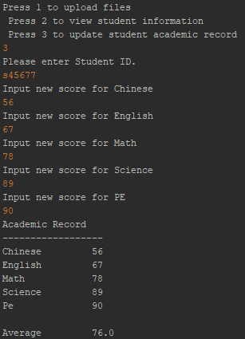

## Component Test

* Assign Role

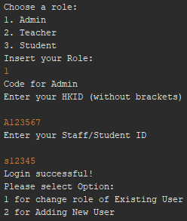

* Upload assignment

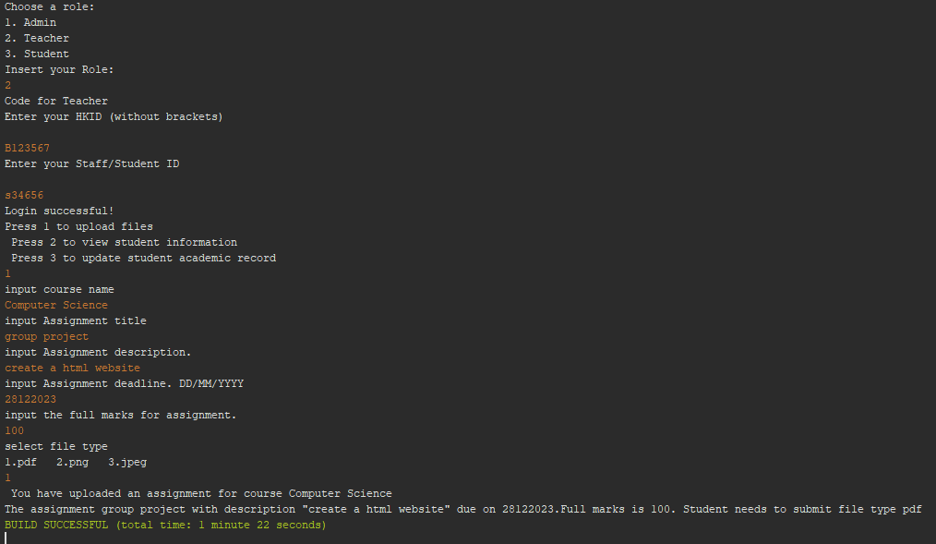

* update

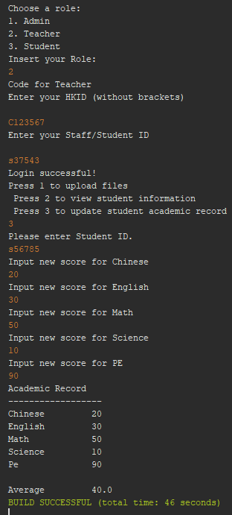

## System Test

* Start from selecting role(Admin) and login, end at assigned role

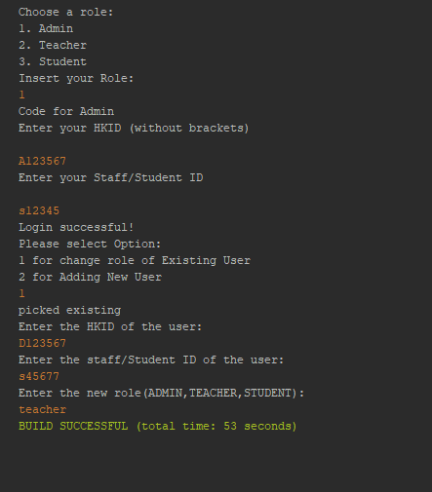

* Start from selecting role(Teacher) and login, end at uploading file

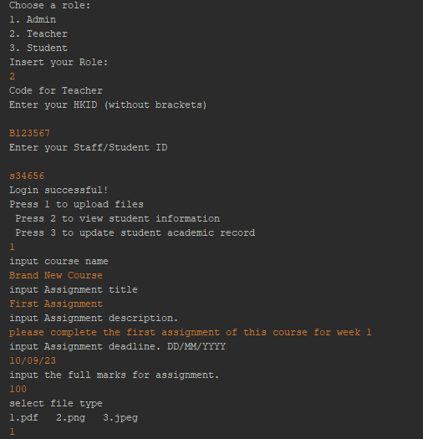

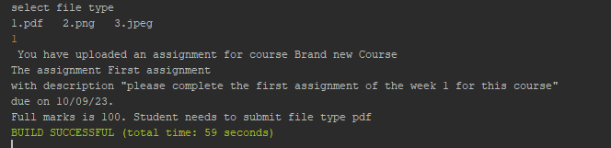

* Start from selecting role(Student) and login, end at viewing academic record

